Appendix: Segregation Statistics

Exposure rates

In this report we used exposure statistics to measure segregation and to capture the experiences of segregation. Exposure of certain racial groups to one another or to majority groups shows the distribution of racial groups among organizational units – states in this report – and describes the average contact between different groups. It is calculated by employing the percentage of a particular group of students of interest in a small unit (e.g., school) with a certain group of students in a larger geographic or organizational unit (e.g., state) to show an weighted average of the composition of a particular racial group. The formula for calculating the exposure rates of a student in racial group A to students in racial group B is:
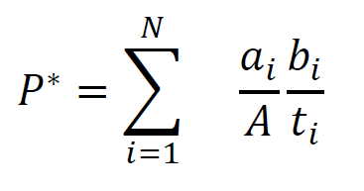

- where n is the number of small units (e.g., school) in a larger unit (e.g., state)
- a_{i} is the number of student in racial group A in the small unit i (school i)
- A is the total number of students in racial group A in the larger unit (state)
- b_{i} is the number of students in racial group B in the small unit i (school i)
t_{i} is the total number of students in all racial groups in the small unit i (school i)

